1. **Write the differences between while and do while loop.**

**While Loop:**

* A While loop is the most straightforward looping structure.
* It is an entry-controlled loop.
* In a while loop, a condition is evaluated before processing a body of the loop.
* If a condition is true, then and only then the body of a loop is executed.

**SYNTAX :**

while (condition) {

statements;

}

**Do While Loop:**

* A Do-while loop is similar to the while loop except that the condition is always executed after the body of a loop.
* It is also called an exit-controlled loop.
* In the do-while loop, the body of a loop is always executed at least once.
* After the body is executed, then it checks the condition.

**SYNTAX :**

do {

statements

} while (expression);

1. **Write simple C# code from notepad and compile it using csc put the screen shot.**

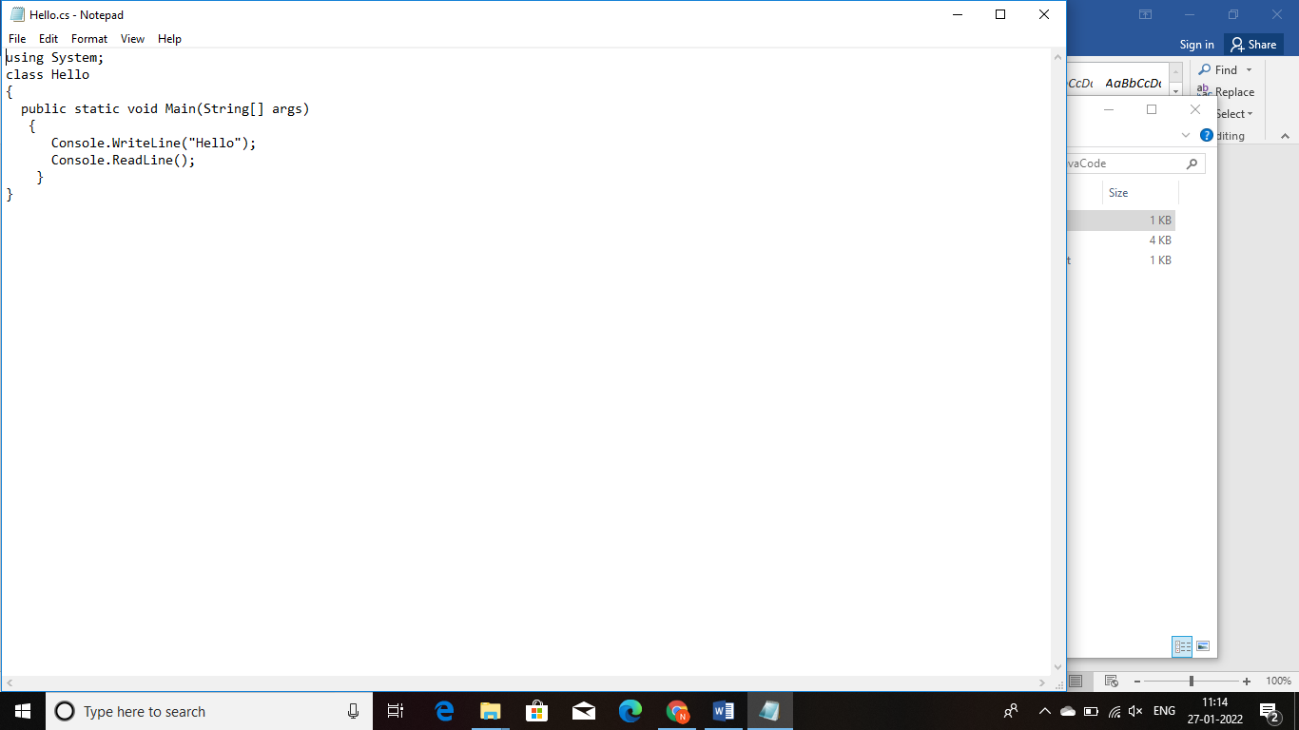

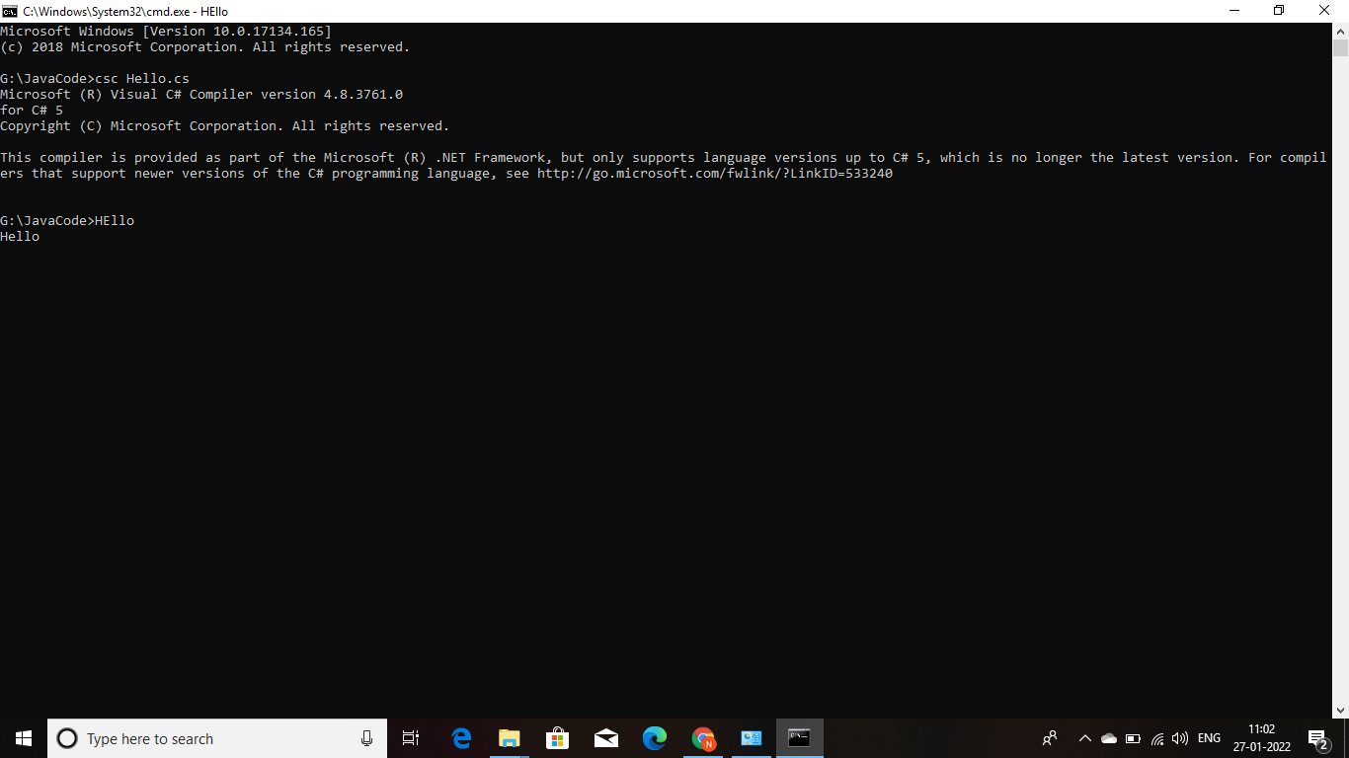

1. **Write the 6 points about arrays discussed in the class.**
2. Collection of similar datatype.
3. Size can’t be increased dynamically.
4. Array index starts from 0.
5. Array requires sequential memory location.
6. When initializing array not need to mention array size.
7. Array variable size = Array length * datatype.